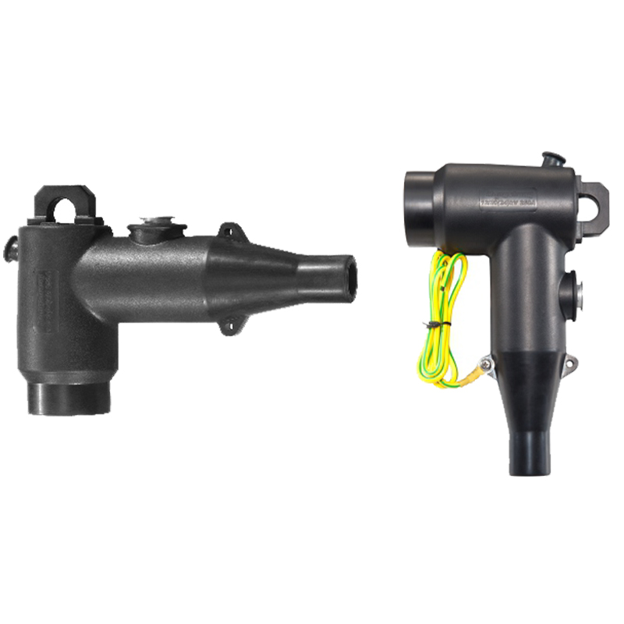
BH-EC
POWER CABLE ACCESSORIES FLYPOWER

250A screened elbow connector
Features/Applications：
BH-EC 250A screened elbow connector, made of EPDM rubber, is used for indoor
Applications. The main body is composed of inner conductive layer, insulating
layer and outer conductive layer, suitable for the connection of XLPE cables
up to 12/20kV to transformers, switchgear, motors and other equipment with
a separable connector.
100% factory tested before shipment, quality guaranteed;
Suitable adaptors（stress cone）easy and simple installation;
The stress cone covers the cable range of 35mm2 -125mm2;
Compact design to suit various installations;
Combined with insulation, sealing and touchable screened;
Meet: IEC60502-4, GB12706.4.
Specification

Size(mm) | Main insulation diameter (mm) | Cable cross-seciton
Size(mm) | Main insulation diameter (mm) | 8.7/15 kV(mm2) | 12/20kV(mm2)
Φ 15 | 18-20 | 35-50 | 35
Φ 18 | 20-23 | 70-95 | 50-70
Φ 21 | 23-26 | 120-150 | 95-120

Technical Data

Performance | HCE-102 | HCE-202
Rated voltage | 8.7/15（17.5）kV | 12/20（24）kV
Max. system voltage | 17.5kV | 24kV
Continuous current | 250A | 250A
Partial discharge | 15kV/≤10pC | 20kV/≤10pC
A.C withstand voltage | 39kV/5min | 54kV/5min
Thermal short circuit | 22.8kA/2s | 24kA/2s
Dynamic short circuit | 80.8kA/10ms | 84.8kA/10ms
Design and structure (mm)
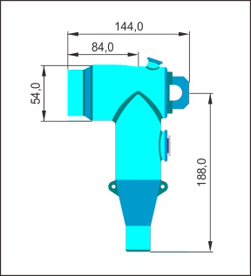
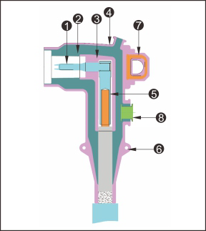
Pin contact
Insulating layer
Inner screen
Outer screen
Compression lug
Earthing eye
Pulling eye
Testing point
Main Compounds
Elbow Connector body Pin Compression lugs
Mechanical metal pad Special pin Spanner

Conductive rod

